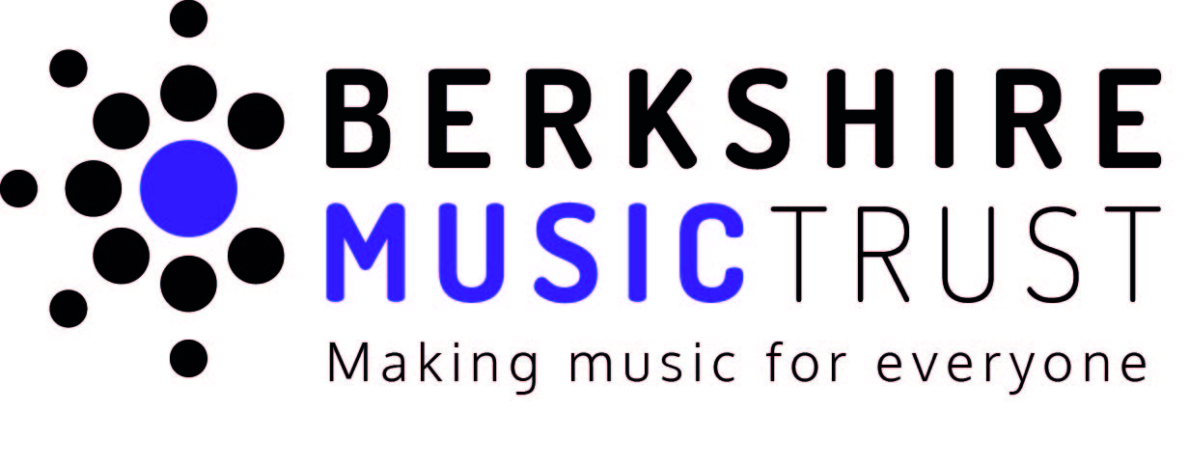

**Youth Trustee**

**Location:** Reading, hybrid, or online  
**Contract Type:** Minimum commitment of one academic year

**Hours:** 6 meetings annually, of approx. 2.5 hours in length

**Salary:** This is a voluntary position

Berkshire Music Trust - Our Mission

“Our vision is to enhance and enrich the lives of children, young people, and adults through the unrivalled range of musical opportunities we offer”

Foreword by Jon Carroll - Chair of Trustees

Are you passionate about music and eager to make a difference? We're looking for a dedicated member of our Young Musicians' Council to join our Hub Board as the "Youth Voice.” In this role, you’ll help shape the future of music education in Berkshire, ensuring it meets the needs and interests of young people. This is your chance to inspire change, share your ideas, and be a key part of our mission to grow and nurture the next generation of musicians. Your voice matters—help us make it heard in this fast-changing world!

Why Become a Youth Trustee?

We are all about working within our communities with, and for our young people to inspire them and develop them as young musicians. Primarily, we work with young people, but we can't do this on behalf of young people without talking to them, without understanding their needs, their interests and how we can do our very best to support them.

This is particularly important right now, at a time when the context young people are living in changing faster than they ever have before. From the ongoing effects of the COVID-19 pandemic, to technological advancements, its never been more important for young people to have the opportunity to take control of their music going into the future.

We already have a Young Musicians Council, and we want to enhance this with a youth trustee on our board to help it’s continuing development and provide some authentic youth leadership - ensuring we are listening effectively to our young people.

About You

* Passionate about Music, and its transformative power to change lives
* Experience of learning or making music of any kind (Experiences within Berkshire preferred)
* Aged 18 - 25 (or up to 30 for those who identify as disabled)
* Display a growth mindset, with willingness to take on new challenges and develop your skills and experiences
* Committed and driven individual, able to take on the role for a minimum term of one full academic year
* Berkshire Music Trust (previously known as Berkshire Maestros) alumni encouraged to apply, but previous engagement with us is not essential.

About the Role

* Attend Trustee meetings, in-person or online. There are 6 meetings throughout the academic year, and they fall on Tuesday evenings.
* Be an active part of, and provide some leadership to our Berkshire Young Musicians Council, helping them move their ideas into actions.
* Collaborate with the Youth Engagement Lead to create reports based on research insights that inform stakeholders about the contexts, needs, and preferences of children and young people within the Local Music Hub.
* Make the role your own! - This is our first time actively seeking a Trustee in this specific age range, and we invite you to bring your unique experiences and insights on how the role can best drive positive change.

What is the Berkshire Young Musicians Council?

The Berkshire Young Musicians Council, or BYMC is our platform for young people aged 14+ to have their say on matters that mean the most to them in their Music Hub.

The BYMC has evolved from our previous Youth Advisory Board to a more engaging and member-focused model. Instead of large corporate-style roundtable meetings, we now use creative workshops, smaller ‘Action Groups’, and occasional one-on-one check-ins with the Youth Engagement Lead. Activity timings are flexible, important discussions are recorded and shared securely online, and we communicate using platforms like ChatPro, a WhatsApp-like service that allows members to message each other in a familiar way while ensuring online safety, confidentiality, and adherence to our safeguarding policy.

As Youth Trustee, you’ll play a crucial role in guiding the BYMC, and ensuring their work is embraced throughout the organisation, from the Trustee level downwards.

How To Apply

As this is a fully fledged Trustee role, applications must follow the standard selection and appointment procedure. However, we are aware that applicants for this role are likely to be applying for this type of position for the first time. Because of this, we want to make the application journey as accessible, friendly, and easy as we can.

We are doing this by starting the process with a short expression of interest form, followed up with an invitation for an informal introductory chat with a member of our team.

We will be able to give full info on the official application process at this point, and answer any questions you may have about the role and recruitment process.

[Click Here For The Expression of Interest Form](https://forms.office.com/Pages/ResponsePage.aspx?id=Fk5jY1cPIUmM-zirfktN8jWmPG2Com1KpHKB9hOd66dUQlI4MjZWUjJONjRTT0RUR0Q2RDlPQUE4Vi4u)

We will keep this form open until 1st November 2024, after which you can still get in touch about the role via email - contact@berksmusictrust.org.uk

If you would like to know more about us and our work, we have lots of detailed information at https://www.berksmusictrust.org.uk/about/