Ukulele

Love Me Do

The Beatles

Harmonica part: (Repeat as necessary)

A screenshot of a cell phone

Description generated with very high confidence

Drunken Sailor

Sea Shanty

A close up of a logo

Description generated with very high confidence

Stay With Me

Sam Smith

A close up of a logo

Description generated with very high confidence

Shake It Off

Taylor Swift

A close up of a logo

Description generated with very high confidence

Hound Dog

Elvis Presley

A screenshot of a cell phone

Description generated with very high confidence

Imagine

John Lennon

A screenshot of a cell phone

Description generated with very high confidence

Can’t Stop the Feeling

Justin Timberlake

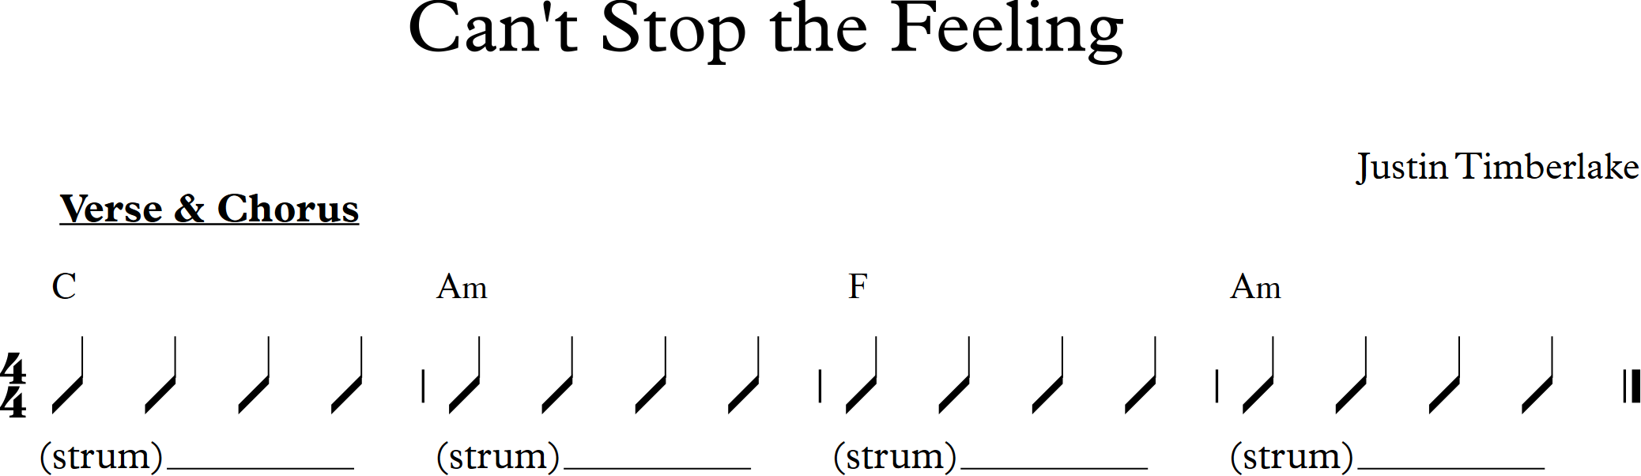

Dreaming of You

The Coral

A screenshot of a cell phone

Description generated with very high confidence

These Days (feat. Jess Glynne)

Rudimental

A close up of a mans face

Description generated with high confidence